DeLong and Summerss:

March 14, 2012

Lunch: March 14, 2012: The Not-So-Simple Arithmetic of Fiscal Policy in a Depressed Economy

The Not-So-Simple Arithmetic of Fiscal Policy in a Depressed Economy
Conventional Normal-Time Analysis: The conventional analysis of a debt-financed boost to government purchases ΔG calculates that its effect on the present value of future output ΔV is:
where (i) μ is the policy-relevant net-of-monetary-offset multiplier, (ii) ξ is the fiscal drag—the future output lost as a result of raising a dollar of tax revenue through distortionary taxes—and (iii) τ is the baseline tax rate needed to finance ongoing government expenditures.
The underpinnings of equation (1) are straightforward. More government purchases this period, amplified or damped by the net-of-monetary-policy-offset Keynesian multiplier, produce more spending, production, and employment now. Some of the current-period cost is recaptured because the extra workers pay taxes. The actual increase in debt is not ΔG, but rather (1-μτ)ΔG. And amortizing this debt requires taxes in the future that act as a drag on enterprise.
In normal times, equation (1) will be strongly negative. Think of a value of 0.5 for ξ and of 1/3 for τ. Then (1) will be negative as long as:
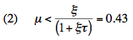
And in normal times μ will indeed be lower than 0.43, perhaps by a considerable margin.
The monetary authority, in normal times, has strong views about the appropriate level of economy-wide spending. It focuses on its price-level target. It seeks a level of economy-wide spending consistent with that target. It will thus damp most if not all of the effect on spending from the increase in government purchases ΔG. It will make the multiplier μ small—if not zero.
By contrast, the fiscal drag ξ for raising tax rates is always there and can be substantial. Only if the shift of demand away from private to public purposes were very highly valued indeed, could there possibly be offsetting benefits that would outweigh (2). Absent such an extraordinary need to boost government purchases, raising government purchases is not a good idea—in normal times.
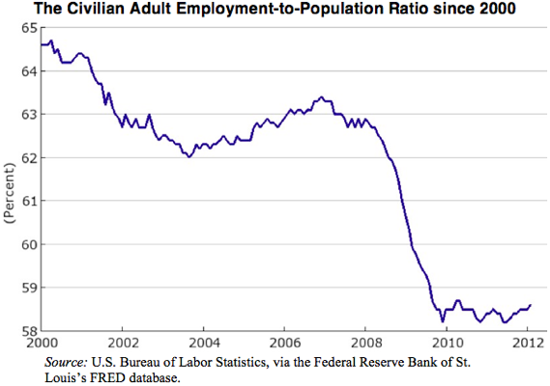
This Time, It Really Is Different: But right now things really are different:
- Right now the monetary policy regime is not one of substantial monetary-policy offset, but rather of amplification of the “bare” constant-monetary-and-financial-conditions Keynesian multiplier. Right now the monetary authority welcomes assistance in boosting output from the other branches of government. It has committed itself to keeping short-term safe nominal interest rates at their zero nominal lower bound. It will do so even should fiscal expansion raise the expected future price level somewhat. Thus μ is not zero, but, unusually, relatively high.
- Right now there is a wedge between the rate at which the Treasury can borrow r and the social rate of time discount r^{d}.
- The current deep recession is going to cast a shadow on the future. A reduction in current real GDP of $1 carries with it a reduction in future potential output equal to some hysteresis parameter η. And this hysteresis shadow is a long-run phenomenon. It decays only at some rate φ.
- Expansionary fiscal policy now damps the downturn, reduces the shadow, and raises future output. Thus it reduces the baseline tax rate needed to finance ongoing government operations. Such tax-rate reduction carries with it a fiscal dividend: lower tax rates boost output in the future.
Equation (1) thus is transformed into:
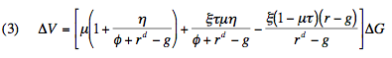
where g is the long-run growth rate of potential output.
While the normal-time (1) is almost surely negative, its right-now counterpart (3) is almost surely positive.
Expansionary Fiscal Policy and the Burden of Government Debt: Look first at the government-finance terms in (3): Expansionary fiscal policy raises the present value of the government’s future incoming cash flow by:
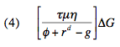
It increases the present value of future spending on debt amortization by:
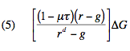
As long as:
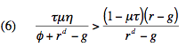
holds, expansionary fiscal policy in the present:
• boosts present-period output via standard Keynesian multiplier channels,
• increases future output by diminishing the shadow cast on future potential output by the current downturn, and
• further increases future output by improving the government’s long-run fiscal balance and thus diminishing the fiscal drag from taxation.
As long as (6) holds, there is no benefit-cost calculation to be made. Expansionary fiscal policy has no costs, only benefits.
Does (6) hold? Auerbach and Gorodnichenko (2012) estimate a recession-period multiplier μ comfortably more than 2.5. The Congressional Budget Office (2012) appears to assume a hysteresis parameter η of 0.2. It has marked down the future growth path of potential output in the wake of the current downturn by such a margin. The baseline tax rate τ is about 1/3. 4%/year is a reasonable social rate of time discount. 2.5%/year is the projected growth rate g of potential output. Assume a value of 0.05/year for the hysteresis-decay parameter φ—a parameter about which we know nothing.
Solving (6) for the Treasury real borrowing rate r reveals that (6) holds as long as:
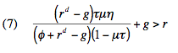
And for these parameter values, that means that:
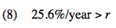
is the critical value of the real Treasury borrowing rate. If the Treasury can borrow below this rate, fiscal expansion does not damage but rather improves the government’s long-run cash flow.
Now perhaps you choose a Ramey (2011) multiplier of 1 (which incorporates substantial monetary policy offset via leaning against the wind by the monetary authority). Perhaps you reject a depressed-economy multiplier of 2.5. Perhaps you choose a hysteresis parameter η of 0.05. Perhaps you reject a hysteresis parameter of 0.2.
Then (8) becomes:
Right now the U.S. Treasury’s real borrowing costs are, for five years, -1.02%/year; for seven years, -0.54%/year; for ten years, -0.07%/year; for twenty years, 0.64%/year, and for thirty-years. 0.95%/year. The weighted real interest rate on U.S. Treasury debt has not been above 3.1%/year for any consistent period in the post-Great Contraction era save for the Reagan years in the immediate aftermath of the Volcker disinflation.
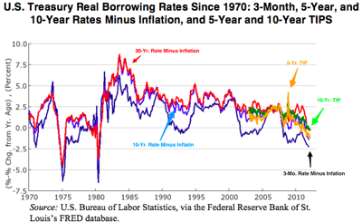
It might be the case that a collapse of the Treasury bond market over the next generation would push the Treasury’s ex post real borrowing rate up above 3.1%/year.
It might.
But that just means that there is a benefit-cost calculation to be made.
Doing the Benefit-Cost Calculation: There are still net benefits as long as:
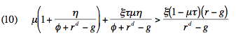
which holds as long as:
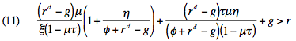
For the parameter values underlying (9), (11) is:
We have already stepped down from a depressed-economy multiplier of 2.5 to a multiplier of 1.0. We have already stepped down to a hysteresis coefficient of .05. Yet we find it expansionary fiscal policy is a good idea, unless it pushes the Treasury’s borrowing rate—and that is the real not the nominal borrowing rate—up to 11%/year.
How much further do we have to push things before expansionary fiscal policy becomes a bad idea at interest rates we might actually see?
Eliminating All Hysteresis Effects: We could eliminate all hysteresis effects whatsoever. We could make the unrealistic and contrary-to-fact assumption that the economy’s long-run growth trajectory has been unaffected by the current downturn We could claim that potential output would in no wise be boosted by a quicker cyclical recovery.
That would get us all the way back to:
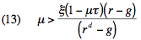
or:
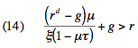
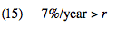
Is there a case for thinking that the current depressed-economy multiplier μ is much less than one? Is there a case for thinking that the fiscal drag on output from raising additional tax revenue ξ is much more than .5? Is there a case for thinking that even a full-blown US sovereign debt crisis would cause real Treasury borrowing rates to rise to 7%/year?
I, at least, find it hard to think so.
The United States borrows in its own currency. A U.S. sovereign debt crisis entails a fall in the value of the dollar below purchasing power parity, a steep reduction in the foreign-currency value of the national debt, and expected subsequent appreciation: that is not a scenario in which real home-product interest rates spike and remain high.
How Low Would the Multiplier Have to Go?: It is possible to turn the question around, and ask: Suppose that the United States loses its exorbitant privilege—loses its ability to borrow at less than the social rate of discount. In that case, how low does the multiplier μ have to go in order for expansionary fiscal policy to be a bad idea?
The answer to that is simply equation (2):
As a last ditch effort, a critic might complain that the taking of present values is inappropriate. Present value is not a welfare measure. Changes in demand-determined production today produce first-order welfare gains proportional to the increase in production: it is not as though to-day’s cyclically non-employed are deriving great enjoyment from their leisure. But changes in supply-side production in the future are worth only the utility of higher output minus the disutility of increased leisure. This point has some force. But it goes the wrong way: it greatly reduces the welfare value of the drag on the economy from the requirement to raise tax revenue in the future to amortize the debt, and that is the sole significant cost of expansionary fiscal policy. The benefit-cost ratio improves
No hysteresis effects, no interest rate discount for U.S. Treasuries as safe assets in what is now a grossly risky world economy, and a multiplier less than 0.43 even though the monetary authority is not leaning against the fiscal wind but rather cheering expansionary fiscal authorities on—you have to work very, very hard indeed to conclude that the arithmetic tells us that the U.S. would not benefit from additional expansionary fiscal policy, as long as the economy is in anything like its current situation.
07:39 PM in Economics, Economics: Federal Reserve, Economics: Finance, Economics: Fiscal Policy, Economics: Macro, Highlight, Obama Administration | Permalink

Comments
Robert Waldmann said...
Very nice. I do object to one word " extraordinary " in " absent such an extraordinary need to boost government". My now familiar argument is that, given the equation, if it is not good policy to raise government spending, then it is good policy to cut government spending. I now suggest a parameter for the relative social value of goverment and private spending call it nu so welfare = Y + (nu-1)G. If nu is 1+ zeta, then G is right when mu =0. How low does it have to be for optimal delta G in a depressed economy to be negative ? Clearly in the first not cost benefit case, 0 is high enough. For mu = 1, the only good terms left are mulitples of eta -- the only good effect is due to hysteresis. I think equation 12 becomes arounf 6.5% > r ( doing all arithmetic in my head so prob 0 I got it all right).
Also how about pay back in 30 years with constant increase in T. The advantage is, for a small increase in G, you have all relevant r. No need to forecast as Treasury can sell 30 year TIPS. Of course for a non tiny increase in G you still need to guess what r will be once policy announced, but will no all you need to know before it's too late (policy sell at some minumum price all the bonds you can up to a ceiling, then spend the proceeds). Worth the arithmetic bother ?
ReplyMarch 14, 2012 at 09:01 PM
Craig H said...
I love reading through your analyses. I do have a few objections to the way you cast things, both in ordinary times and in extraordinary times. Specifically, you speak of zeta, the fiscal drag coefficient, as being "future output lost... through distortionary taxes".
As a matter of personal preference, I am not fond of the habit of economists to refer to taxes as distortionary -- it tends to imply a perfect utility-maximizing state of market investment in the absence of taxes. To my mind, the truly distortionary effects lie in the fact that the market does not internalize externalities. An optimal (or even good) taxation and spending policy by the government can (and does) correct for that to a certain extent. Now I'm aware that economists (at least the self-aware ones) do not believe in a tax-free utopia, and that you are referring to how a change in policy from the current baseline will change market investment, but...
Second, you are implicitly assuming that any taxation/spending comes with the same drag coefficient zeta. But zeta depends crucially on where/who the government is getting the money from, and what the government is spending it on (technically, spending policy can change mu and g, but g doesn't show up in your original equation). I would argue that even in ordinary times, there are policies that produce a negative zeta -- in fact, one of the thing Congress tries to optimize its large taxing and spending bills for is a small or negative drag on GDP. Everyone who says, for example, that we would be better off if the capital gains tax rate were back at 35% is implicitly making a similar statement.
ReplyMarch 15, 2012 at 07:04 AM
Krzys said in reply to Craig H...
Taxes are always distortionary in the sense that the individual decision is suboptimal, given the existing prices. Maybe some of the prices are inefficient for whatever reason, but then the appropriate tax is not a generic income one, but one directed towards fixing a particular inefficiency.
It is not an issue of anyone's preference, but of basic algebra.
Reply

